-- Detyre per fundjaven:

-- Ne tabelat 1) Production.WorkOrder dhe 2) Production.WorkOrderRouting tregohen –

-- detyrat qe u jane dhene punonjesve

-- te kompanise. Ne rastin e kompanise AdventureWorks, tabelat tregojne detyrat e

-- punonjesve te magazines.

-- Duam te bejme nje analize te detyrave te kryera nga punonjesit dhe magazines.

-- 1. Tregoni sa sasi produktesh jane bere Scrap, dhe sa perqind e Scrap nga Stocked

Quantity

-- a. Sa lek kemi hedhur poshte duke shumezuar cmimin e produktit (nga tabela

Production.Product) me sasine e Scrapit.

-- 2. Analizoni Planned Cost vs Actual Cost te taskeve ne tabelen

Production.WorkOrderRouting

-- a. Mesatarisht sa dite me vonese e fillojne punonjesit punen per taskun duke

krahasuar ScheduledStart vs Actual StartDate.

Use AdventureWorks

Go

--1—M1--

go

alter procedure Production.workerorderScrap(@ProductId int )

as

Begin

Select pp.ProductID as Id_Product,wo.ScrappedQty as ScrappedQuantity , percentScrapStock = (wo.ScrappedQty/wo.StockedQty)*100,

ScrapAmountMoney = wo.ScrappedQty * pp.ListPrice

From Production.WorkOrder wo inner join Production.Product pp on wo.ProductID = pp.ProductID

WHERE pp.ProductID>@ProductId

Order by pp.ProductID

end

GO

-----------------------------------------------------------

Commands completed successfully.

Completion time: 2024-09-08T16:51:59.8537630+02:00

--------------------------------------------------------------

EXEC Production.workerorderScrap @ProductId = 0

GO

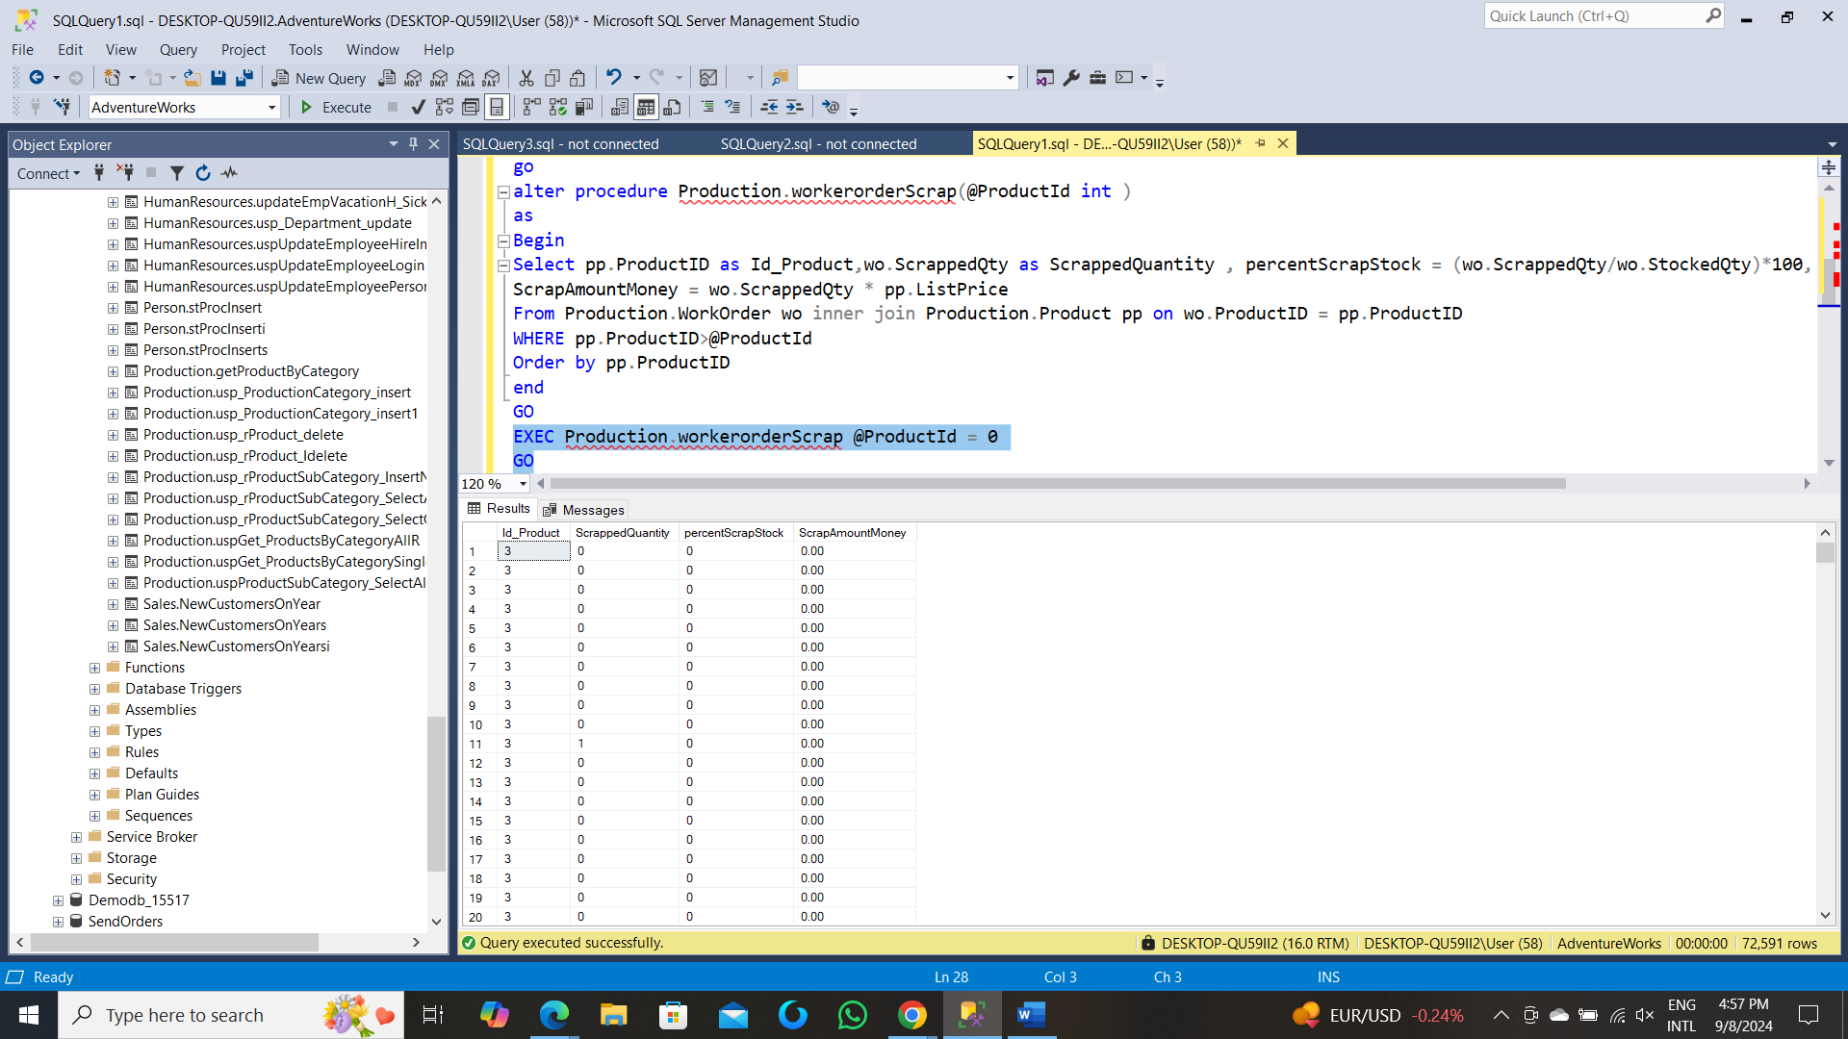

--M2--

go

Create procedure Production.workerorderScrap1(@ProductId int )

as

Begin

Select pp.ProductID as Id_Product,Sum(wo.ScrappedQty) as ScrappedQuantity , percentScrapStock = (sum(wo.ScrappedQty)/sum(wo.StockedQty))*100,

ScrapAmountMoney = Sum(wo.ScrappedQty * pp.ListPrice)

From Production.WorkOrder wo inner join Production.Product pp on wo.ProductID = pp.ProductID

WHERE pp.ProductID>@ProductId

group by pp.ProductID

Order by pp.ProductID

end

GO

Commands completed successfully.

Completion time: 2024-09-08T17:02:07.1974866+02:00

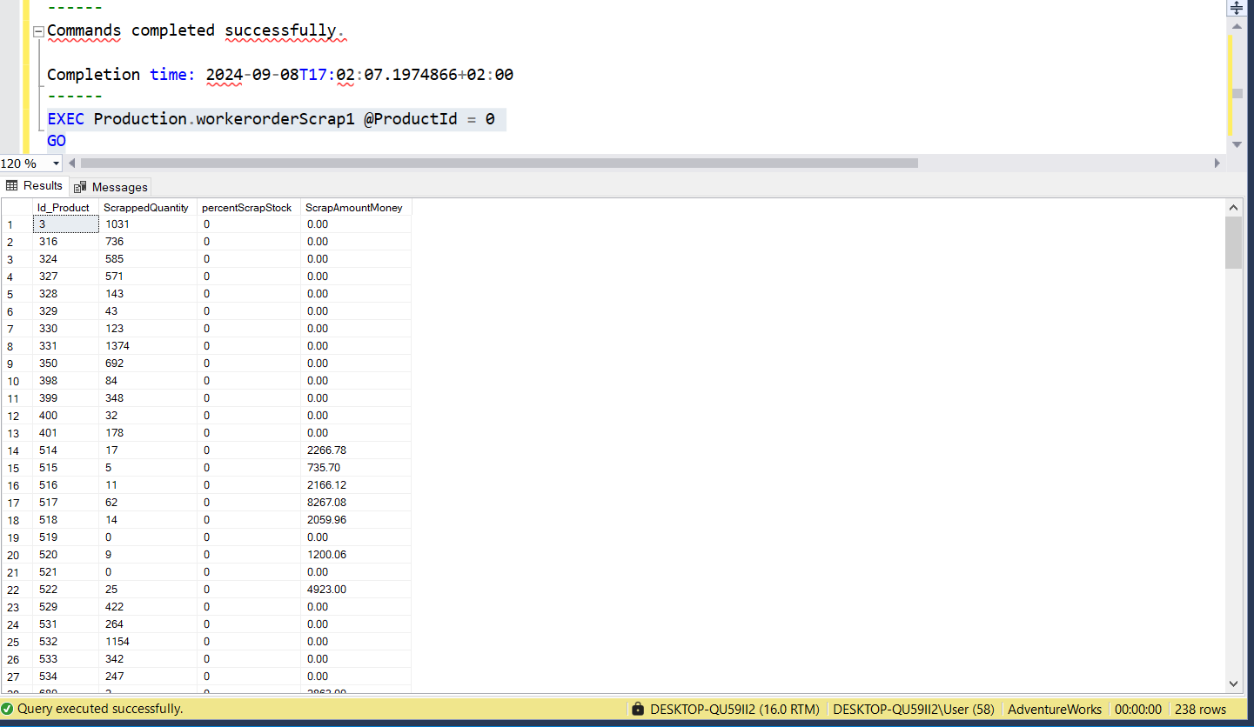

--M3-------------

go

Create procedure Production.workerorderScrapTotal

as

Begin

Select Sum(wo.ScrappedQty) as ScrappedQuantity , percentScrapStock = (sum(wo.ScrappedQty)/sum(wo.StockedQty))*100,

ScrapAmountMoney = Sum(wo.ScrappedQty * pp.ListPrice)

From Production.WorkOrder wo inner join Production.Product pp on wo.ProductID = pp.ProductID

end

GO

Commands completed successfully.

Completion time: 2024-09-08T17:07:38.2361874+02:00

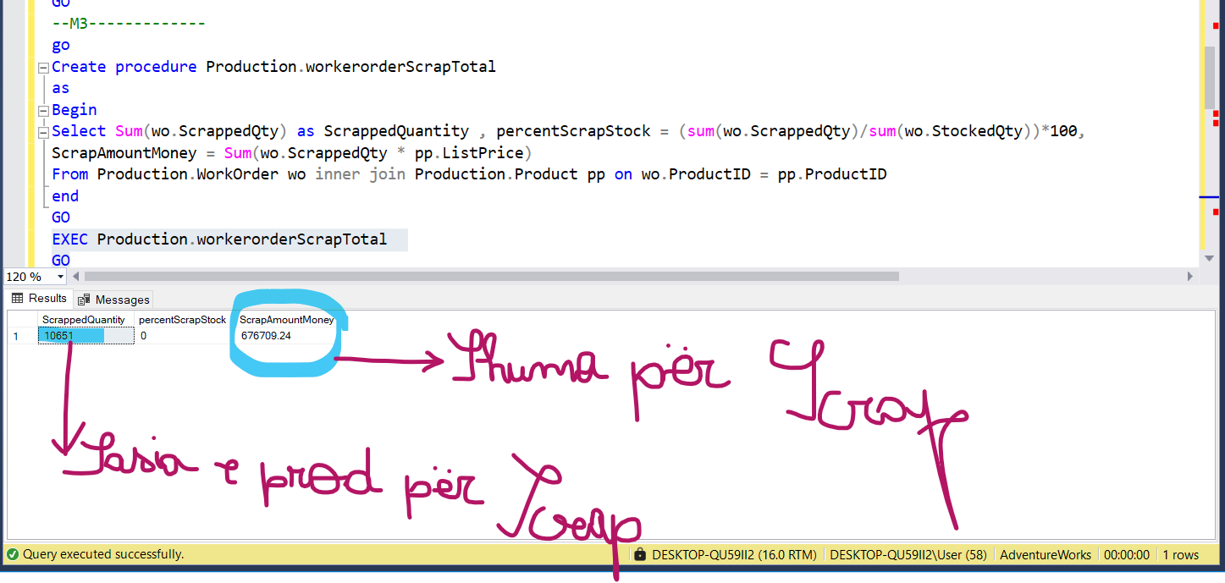

--2--

go

alter procedure Production.workOrderRoutingg(@TaskId int)

as

begin

Select WorkOrderID TaskId,diteShteseFillimi=Sum(datediff(day,ScheduledStartDate,ActualStartDate)),

diteShtesePerfundimi =Sum(datediff(day,ScheduledEndDate,ActualEndDate)),kostoShtese = Sum(ActualCost - PlannedCost)

From Production.WorkOrderRouting

Where WorkOrderID>@TaskId

group by WorkOrderID

end

go Commands completed successfully.

Completion time: 2024-09-08T16:34:34.9853179+02:00

exec Production.workOrderRoutingg @TaskId = 0

go

Select * From Production.WorkOrderRouting

